Home-Built Windmill

In the late 1990’s I developed an interest in windmills. I was constructing a pond on my property and was interested in using a windmill to provide a supplemental water source for it and for aerating of the water. Initially I followed the classified ads and farm auctions looking for a restoration project but soon I got stuck on the idea of designing and building my own. I started collecting literature and studying the many design approaches from the past and started putting sketches together. The Vintage Windmill website was one of my sources of information and answers to questions. Finally, a trip to the Windmill Tradeshow in 1999 let me look at a variety of iron and put it all in perspective.

I decided to take a conservative approach and build a traditional farm type, multi- blade windmill. What I ended up building has a fan diameter of 9.5 feet, a tower height of 44 feet, a gear down ratio of 3:1 and 9 inch stroke that can be increased to 18 with a lever mechanism. The fan has 20 blades and a solidity of about 80%.

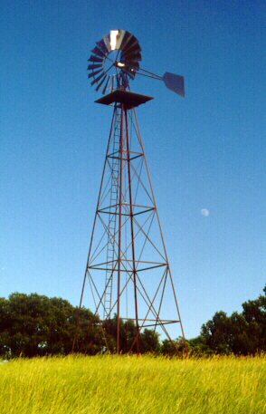
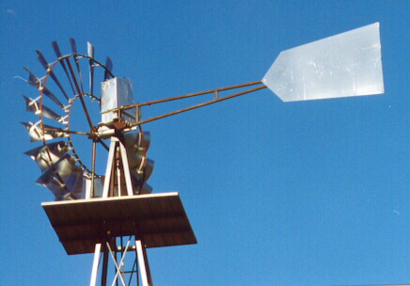

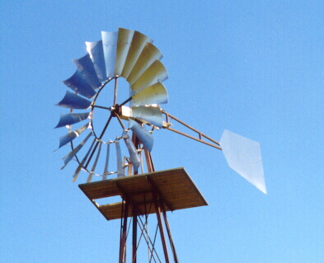

I used a chain drive to provide the gear reduction. This gave flexibility if I decided to change the ratio later. The windmill head is fully enclosed. Lubrication of the chain is through dipping in oil (5W-30). Greased ball or roller bearings are used for all rotating and pivoting bearings. The windmill head housing is a welded fabrication of ½ and ¼inch plate. A #22 gage sheet metal cover is sealed to the lower case with silicon sealant.

A welded fabrication was made to join the 4 legs and support the turntable hub.

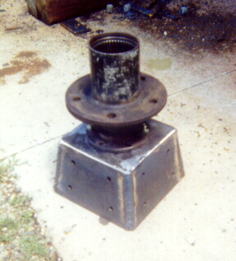

A key element of the design was the selection of the use of front hubs from a Ford 4-wheel drive half-ton pick-up truck for use as the turntable bearing assembly as well as for the hub for the fan. The Ford hubs were robust, and had serviceable bearings. The hole for the axle provided the needed hole for the reciprocating pumping rod in the turntable. The hub used as the fan hub uses an axle end as the drive end of for the shaft from the fan. The manual locking hubs allows the head to be taken out of gear and still allows the wheel to still turn in the wind. I retained the front axle U-joint and welded a section of 1 inch cold-rolled to the cut down axle.
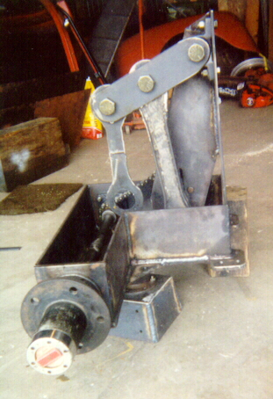

The main drive has a 3:1, #50 roller chain, reduction to drive a fabricated crank. The crank drives a fabricated connecting rod, which drives a lever attached on one end to the windmill head and the other to another connecting rod, which hangs directly above the middle of the turntable. The bottom of this connecting rod connects to a clevis on the end of a piece of ¾ inch rod. This rod, which drives the sucker rod, runs through a bushing pressed in the hole of the turntable wheel-hub. The bushing was fabricated from UHMW polyethylene plastic.

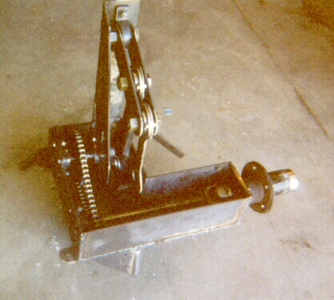

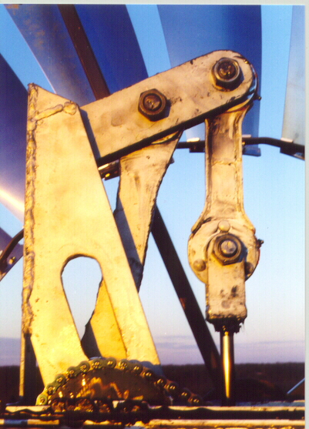

The tower was fabricated from steel and primed with zinc-based primer and painted brown. The legs are each formed with 2-20ft lengths 2½ by 3/16inch angle plus a 4ft-stub tower. 2 by 1/8inch angle was used for cross members and ¾ by ¼ strip for all bracing but the lower section for which 1¼ by 1/8 angle was used. 3/8inch, grade 8, bolts were used for all connections except the foundation attachment that used two 5/8 bolts at each leg. A relatively large 6ft by 6ft platform was fabricated with angle iron and pressure treated 2 by 6’s. A ladder was also fabricated (welded) and fastened to the tower. The tower was fabricated and pre-painted in my shop and assembled on its side about ¼ mile from the site.

The tail was fabricated with 1 inch square tubing and #18 stainless steel sheet. A welded fabricated hinge, using UHMW polyethylene bushing, was made to bolt onto flanges on the windmill head case.

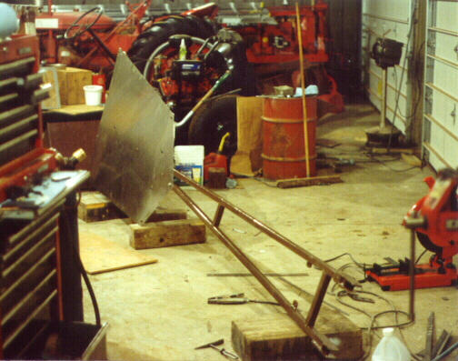

The frame for the fan was fabricated with 1¼ square tubing and steel strip. Lots of geometry work was needed to work out the lengths and bends. The spokes bolted to a round ½ inch plate, at the center. This plate bolted directly to the 5 wheel-lug holes on the hub.

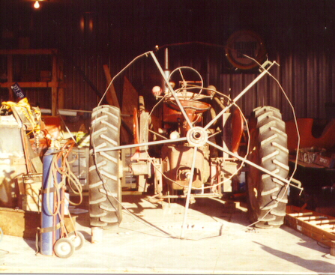

The foundations for the tower consisted of 2½ by ½ steel straps anchored in concrete about 5 feet in the ground. The steel strip was pre-drilled and attached to a temporary frame for leveling before the holes were filled with concrete. The foundation was put in late in the fall and a well was drilled in the spring.

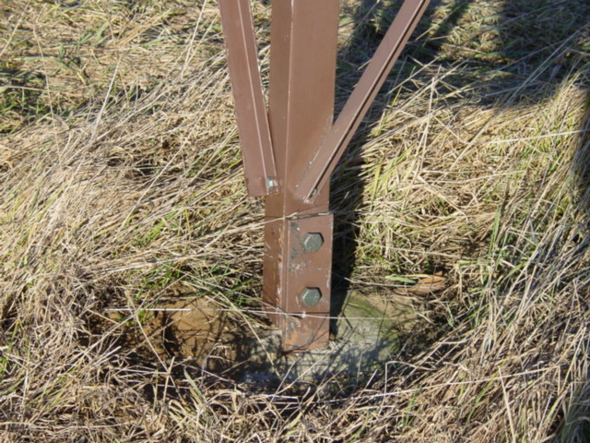

The tower had 2 extra braces and 2 wheels attached to allow it to be pulled to the site with a farm tractor and loader. 2 legs were attached to foundation each with a single 5/8 bolt in preparation for raising it. I hired a sign company to lift it up. By having it ready to lift when the truck arrived, the cost was only $110 and faster and safer than anything I could have done by myself.

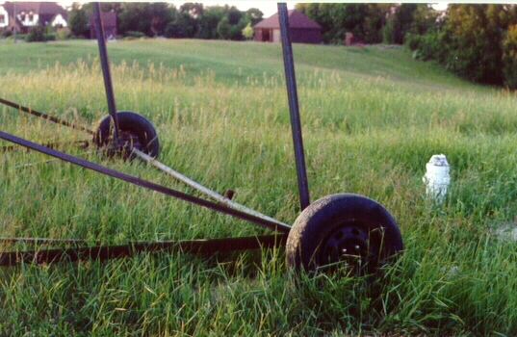

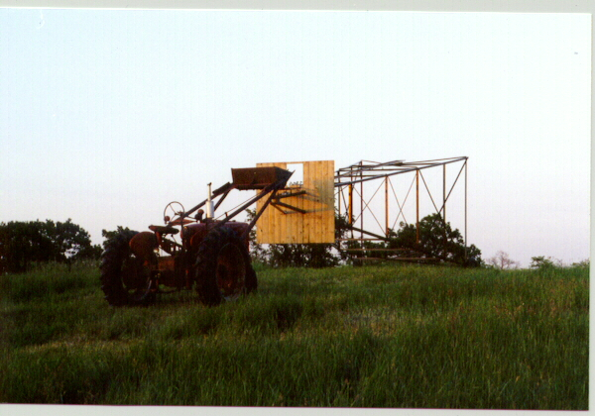

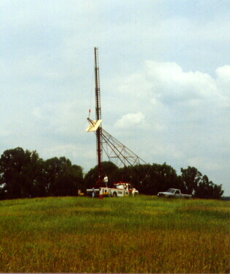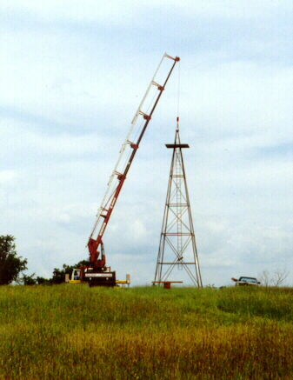

A next step was burying a 1-inch plastic pipe for water and a 3/8inch plastic tube for an aeration line from the windmill to the pond.

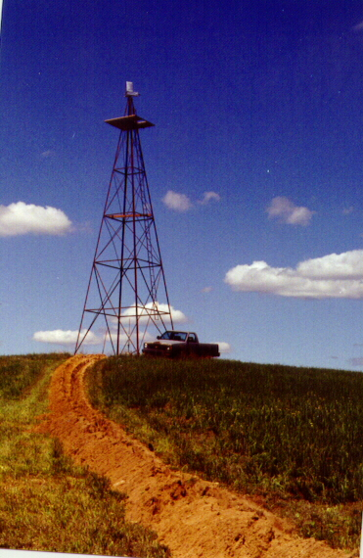
The windmill head was hoisted to the platform by rope and assembled in place along with the tail and wheel frame for the fan. 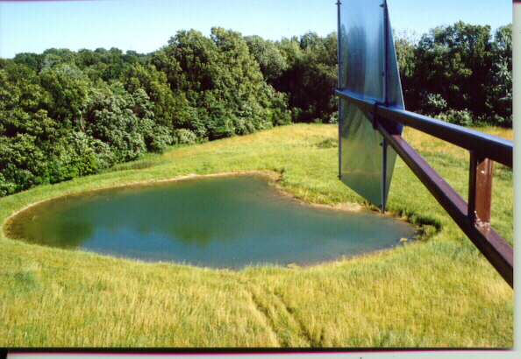

The partially completed windmills stood in my meadow for the winter as a big weather vane while the blades were being fabricated.

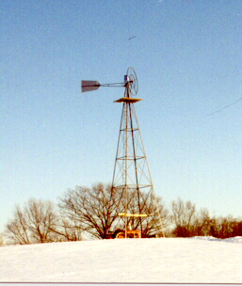

The blades were fabricated from 18gage stainless steel. I would have preferred 20gage, but the 18gage material was available at my steel supplier. The steel supplier was willing to shear out the blade and tail. I rolled the curvature into the blades and drilled five 1/4inch mounting holes. The blades were mounted on fabricated steel brackets and assembled to the wheel frame on top of the tower.

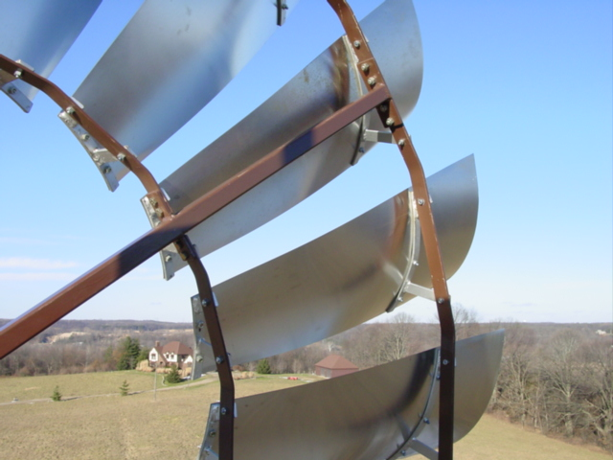

A furling mechanism was designed using an automobile air-shock to provide the force as well as providing damping of the tail motion. The brackets were built with several holes and positions to experiment with adjustment – but the first guess worked out. Adjusting the air pressure allowed setting such that the wheel turns out of the wind in around 30-35 mph gusts. The highest wheel speed I have clocked in a high wind was 109 rpm (10 pump strokes in 16.48 seconds), but 60 rpm is typical for a 15mph wind. Several comparisons of wheel speed to “weather report wind speed” indicate wheel tip speed is running about 1.35 times wind speed.
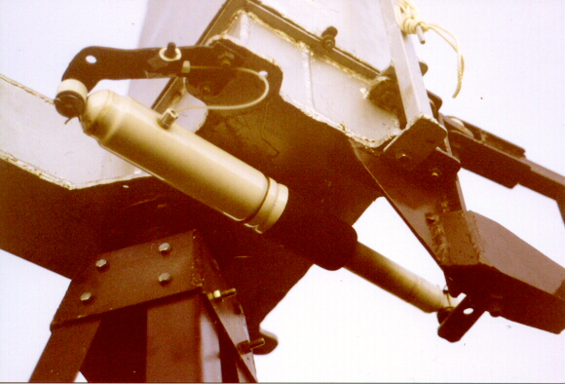

3/8 pipe was used for sucker-rod. Originally I used a conventional direct drive with the 9inch stroke. I made triangular blocks made out of UHMW polyethylene plastic as guides in the 2inch drop- pipe. I made these out of two-inch diameter stock cut one inch thick. I cut them triangular on my radial arm saw and drilled an 11/16 hole for the sucker rod.

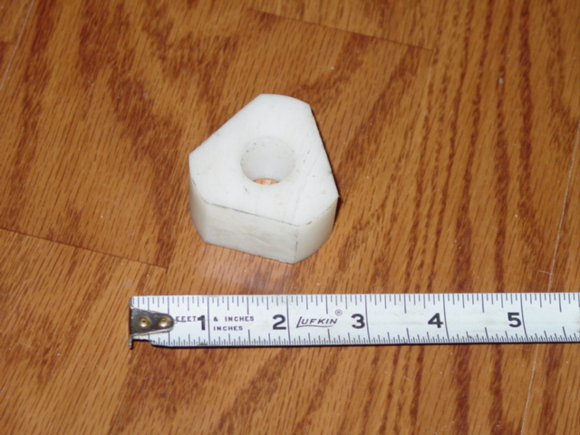

Per a suggestion my well driller, I tried pumping directly on the 2inch, iron drop- pipe. The leathers only lasted about 5 months and were very difficult to pull up when I replaced them (catching at the pipe joints caused the problem). The second set of leathers seems to be lasting better; perhaps the pipe is worn smooth now. I plan to install a1&7/8 brass cylinder I have purchased next time they go bad.

I also have created a variable stroke mechanism using a lever part way up the tower. The sucker rod is connected to an automotive U-joint at one end of the lever and a ¼ inch steel cable is used to connect the lever to the rod from the head. By connecting the cable to one of three positions, strokes of 9, 12, or 18 inches can be set. I also counter weighted the lever with a 25pound concrete block to balance part of the weight of the sucker rod. This helps the mill get started on days when the wind is low.

A doubled 2 by 6 catwalk across the cross members lets me step in to adjust the stroke.

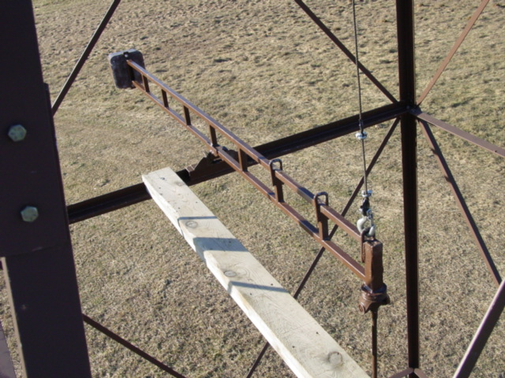

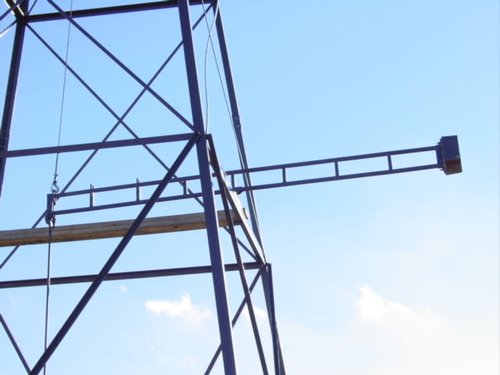

Finally, a neighbors request that I put a flag on the tower after September 11th. I tried hanging it from the platform, but it kept getting tangled in the tower and sucker-rod. Finally I erected a separate mast fastened to the windmill head to fly it above the wheel.
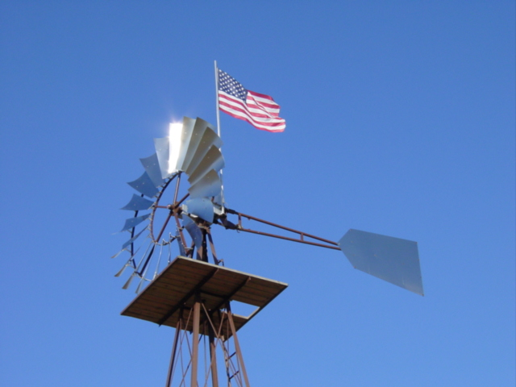

The only unforeseen issue I have had with the design is the need to keep nearly all slack out the chain drive to keep the “clunk” sound down when it reaches the top of the stroke and the load direction changes from drive to driven.

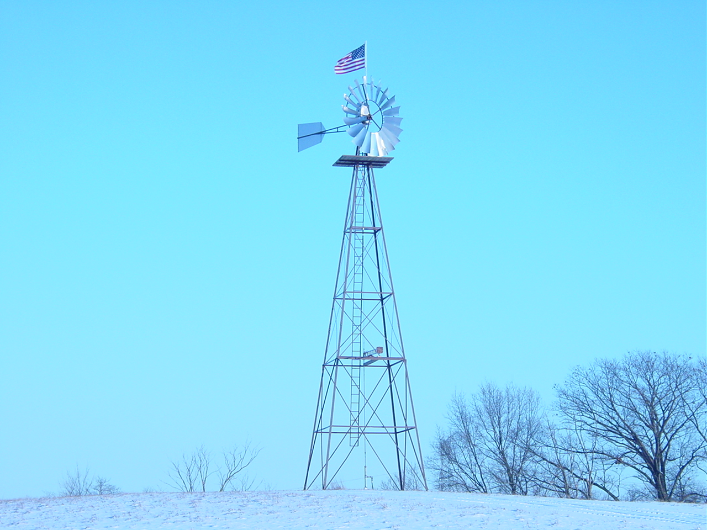

Epilogue 2017: I never added the air-pumping cylinder to use for pond aeration and have generally used the mid stroke pumping position. The windmill has been in continual use with few problems. I have replaced the ball bearings on the connecting rod and crank due to bearing wear out and plan at some time in the future to replace the connecting rod with a more elegant machined one and convert to roller bearings for high load capacity.

The brass cylinder was installed using neoprene seals and has worked out well with the exception of a problem with galvanic corrosion. After only a few years the pump stopped working due to a hole corroded through the galvanized steel drop pipe at the threaded area where the brass cylinder connected (no galvanized coating at the threads). To solve the problem I added a section of plastic pipe between the drop pipe and the cylinder and added a fiberglass sucker rod in the bottom position to electrically isolate the cylinder. This has completely resolved the issue. I have a nylon safety strap between the drop pipe and the cylinder as a safety precaution if the plastic pipe would crack.

After about 10 years a schedule 40 plastic pipe fitting developed crack that progressed about half way around – enough to allow leakage for the pipe to drain back and stop pumping but not to separate. I have since replaced the schedule 40 pipe and fittings with schedule 80 and changed the plastic connecting fitting to female threaded connection for much improved strength.
Also, although the air shock device worked well, for the furling device, I found I needed to replace the device after about 7 years due to loosing charge. About 2 years ago I changed to a fixed coil over shock arrangement. Although not as adjustable, I am finding it works quite well and should prove more reliable.

